INDIA AIR POLLUTION ANALYSIS

DATASET OVERVIEW :
The dataset contains historical air quality monitoring records collected from monitoring stations across multiple and cities in India . It includes measurement of major air pollutants along with station information and sampling dates
Dataset Information:
- Dataset Name: India Air pollution Dataset
- Time Period : February 1990 – December 2015
- Total Records (Original) : 436074
- Records After Removing Duplicate :435400
- Number of features : 13

FEATURES DESCRIPTION
COLUMN | DESCRIPTION
Stn_code | A unique identification number assigned to each air quality monitoring station. It is used to uniquely identify the station where the air quality data was collected.
Sampling _date | Represents the month and year during which the air quality sample was collected (e.g., "February - M021990"). It helps analyze seasonal and monthly pollution trends.
state | State where monitoring station is located
location | City/Location name
Agency | Organization responsible for data collection
Type | Type of monitoring are (Rural)
S02 | Sulphur Dioxide concentration
N02 | Respirable Suspended Pariculate Matter
rspm | Suspended Pariculate matter
spm | Monitoring station name
Location_monitoring _station | PM2.5 concentration . Represents Particulate Matter 2.5 (PM2.5), which consists of extremely fine particles with a diameter of 2.5 micrometers or less.
date | Standardized sampling date
DATA QUALITY ISSUES IDENTIFIED:
The intial dataset contained several data quanity issues the required preprocessing before analysis.
* 674 duplicate records
* Missing values in multiple categorical columns
* missing values in pollutant concentration (So2, N02, RPSM, SPM)
* Missing montoring station names
* missing sampling dates
* four records contained invalid (31/06/2014 , 31 /04/2014)
MISSING VALUES BEFORE CLEANING:
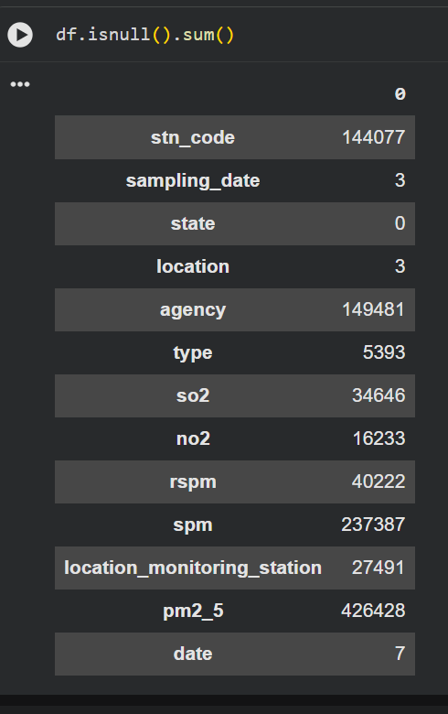
DATA CLEANING :
Remove Duplicates
Duplicate records increase data redundancy and may produce inaccurate results. Duplicate rows should be identified and removed to maintain data integrity.
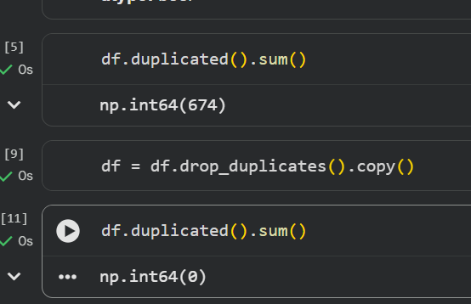
Shape:
Shape of the Dataset:
The shape of a dataset represents its dimensions, showing the total number of rows (records) and columns (features). It provides a quick overview of the dataset's size and structure before data preprocessing and analysis.

Handled Missing Values:
The missing values were handled using appropriate technique based on the nature of each column.
1. Stn_code : Left as missing because it is an unique station identifier and cannot be reliably inferred. 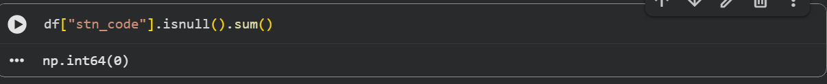
2.sampling_data : Negligible Missing Values
3. Location : Filled using the most frequent (mode) within the corresponding state.
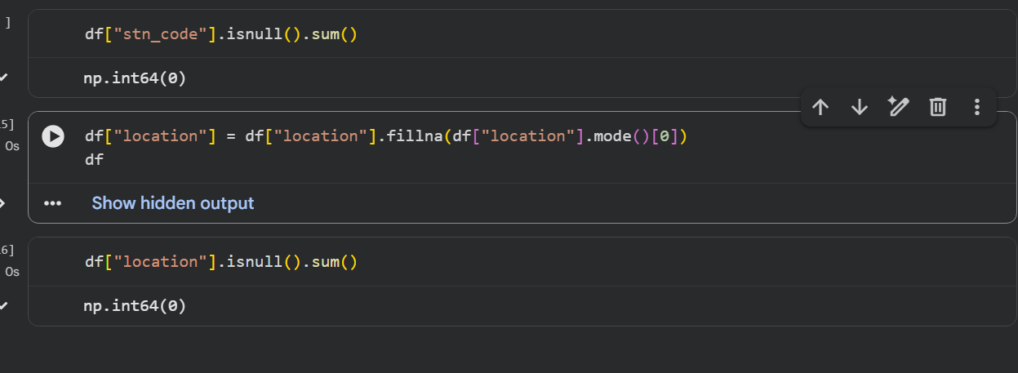

4.categorical columns:
Categorical columns contain text-based or label-based values that represent categories rather than numerical measurements. These columns are used to classify data into different groups and are typically preprocessed by handling missing values, encoding categories, or standardizing labels before analysis.
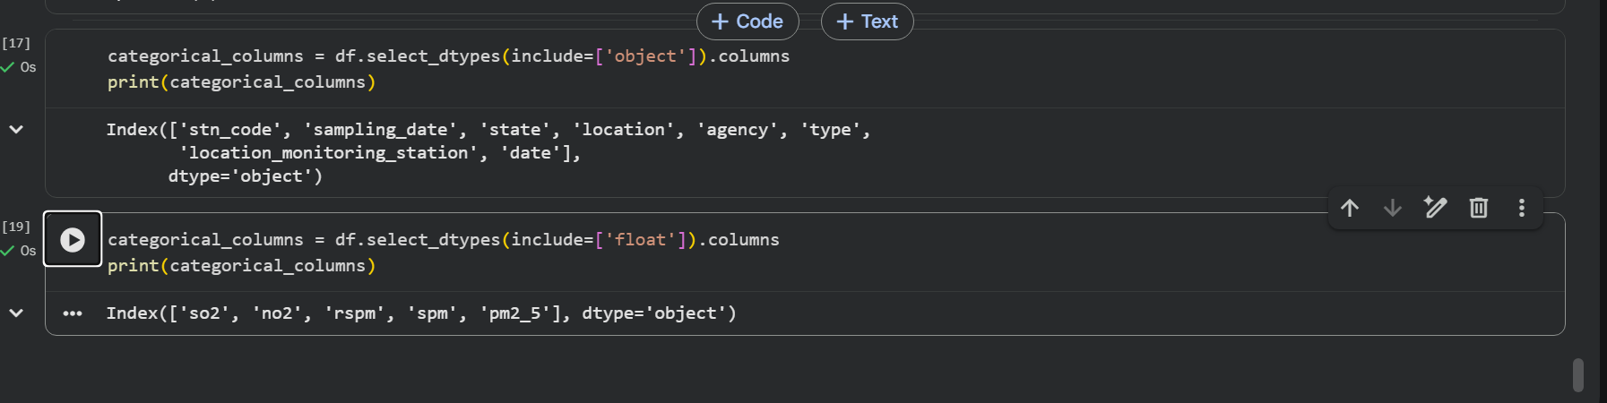
5. Missing Value Imputation
Missing values in numerical columns were imputed using the mean, while missing values in categorical columns were imputed using the mode. This approach preserves the dataset's completeness and prepares it for reliable analysis.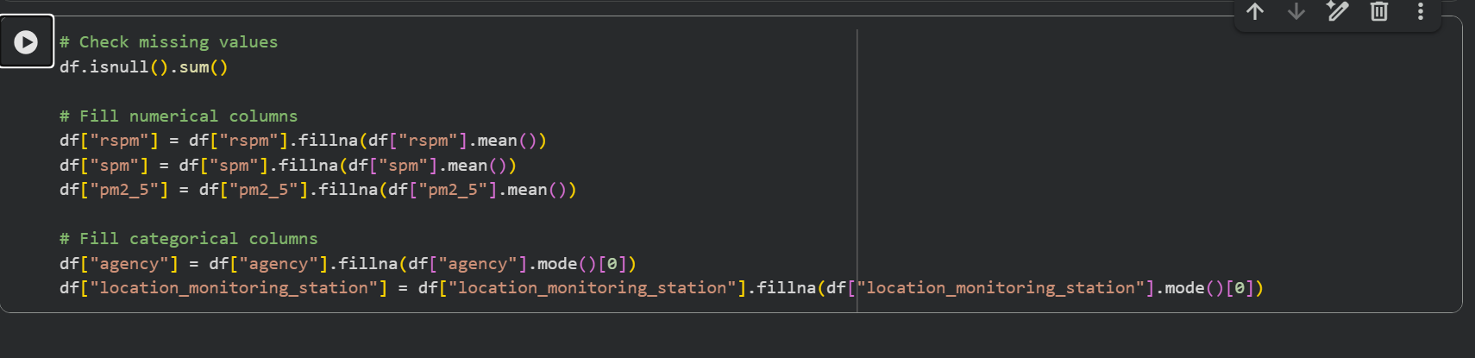
Missing Values After Cleaning
After performing data preprocessing and missing value imputation, the dataset was checked again using df.isnull().sum() to ensure that the missing values were handled appropriately. The remaining missing values, if any, indicate columns that were intentionally left unchanged or require additional preprocessing.
